- Build the truth table and design a digital circuit for the function (2 pkt):
  - f(x,y) = (~x ∪ ~y) ∩ ~(y ∪ ~x)
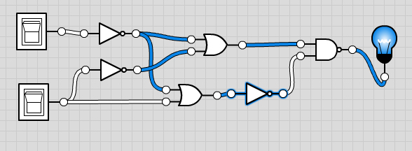
x | y | ~x | ~y | ~x ∪ ~y | y ∪ ~x | ~(y ∪~x) | all
0 | 0 | 1 | 1 | 1 | 1 | 0 | 0
0 | 1 | 1 | 0 | 1 | 1 | 0 | 0
1 | 0 | 0 | 1 | 1 | 0 | 1 | 1
1 | 1 | 0 | 0 | 0 | 1 | 0 | 0

  - f(x,y,z) = ~z ∪ (x ∩ y ∩ ~z)

x | y | z | ~z | x ∩ y | x ∩ y ∩~z | all
0 | 0 | 0 | 1 | 0 | 0 | 1
0 | 0 | 1 | 0 | 0 | 0 | 0
0 | 1 | 0 | 1 | 0 | 0 | 1
0 | 1 | 1 | 0 | 0 | 0 | 0
1 | 0 | 0 | 1 | 0 | 0 | 1
1 | 0 | 1 | 0 | 0 | 0 | 0
1 | 1 | 0 | 1 | 1 | 1 | 1
1 | 1 | 1 | 0 | 1 | 0 | 0

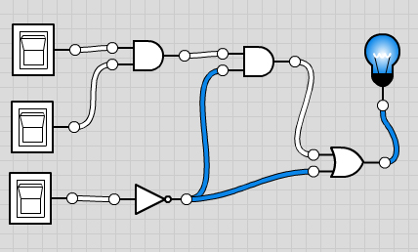

  - f(x) = ~x ∩ x
x | ~x | all
0 | 1 | 0
1 | 0 | 0

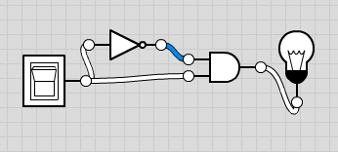

  - f(x,y,z) = x ∪ y ∪ (~x ∩ ~z)
x | y | z | ~x | ~z | ~x ∩ ~z | y ∪ (~x ∩ ~z) | all
0 | 0 | 0 | 1 | 1 | 1 | 1 | 1
0 | 0 | 1 | 1 | 0 | 0 | 0 | 0
0 | 1 | 0 | 1 | 1 | 1 | 1 | 1
0 | 1 | 1 | 1 | 0 | 0 | 1 | 1
1 | 0 | 0 | 0 | 1 | 0 | 0 | 1
1 | 0 | 1 | 0 | 0 | 0 | 0 | 1
1 | 1 | 0 | 0 | 1 | 0 | 1 | 1
1 | 1 | 1 | 0 | 0 | 0 | 1 | 1

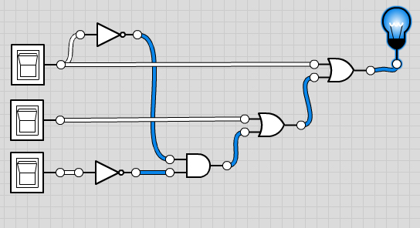
2. Construct a full subtractor circuit (2 pkt).

